0000.doc



SAMPLE EXAMINATION

MODERN HISTORY DOCUMENT BOOKLET
Stage 2

CONTENTS:

Document set | Area of study | Number of sources | Related question
1 | Australia 1880s–1920s | 6 | 1
2 | Australia 1920s–1950s | 6 | 1
3 | Australia 1950s–1990s | 6 | 1
4 | Fascism in Italy 1918–1945 | 3 | 5
5 | Nazism in Germany 1918–1945 | 3 | 5
6 | Civil Rights Movement in the USA 1940s–1970s | 3 | 5

SECTION ONE: DOCUMENT STUDY—Unit 2A
DOCUMENT SET 1
Australia 1880s–1920s

Source 1
(The following extracts are from letters and diaries of soldiers serving on the Western Front in the First World War.)

Soldier (a)
... a shocking bombardment, hell let loose ... it seems as though every gun the enemy possessed was ranged against us ... the Germans set up a cheering and shouting, the like, I have never heard before and simultaneously charged us in mass formation ... It was fearful yet awe-inspiring, for the first few minutes I felt sick, then as steady as a rock, I was right in the line of fire and the shells came straight for my bay... some fellows nerves gave way and they became gibbering idiots, Sergeants and all sorts, god it was little wonder for... fighting here is just simply massacre.

Soldier (b)
... one foggy morning ... we could hear someone over towards the German entanglements calling for a stretcher bearer; it was an appeal no man could stand against; so some of us rushed out and had a hunt; we found a fine haul of wounded and brought them in ... another man about 30 yes [yards] out sang out 'Don't forget me cobber', I went in and got four volunteers with stretchers and we got [him and another man] in safely.

Source 2
(This painting titled The beach at Anzac by Frank Crozier was created in 1919 and is part of the collection of The Australian War Memorial in Canberra.)

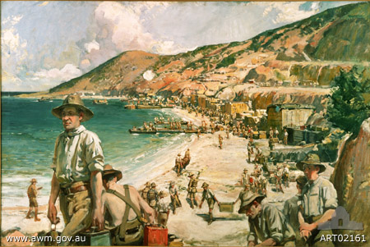

DOCUMENT SET 1
Australia 1880s–1920s continued

Source 3
(In this cartoon, produced late in 1916 by a regular contributor to the Daily Worker, Prime Minister Hughes is holding a circular bomb in his hand. The fuse is burning and its smoke spells out ‘Conscription’.)
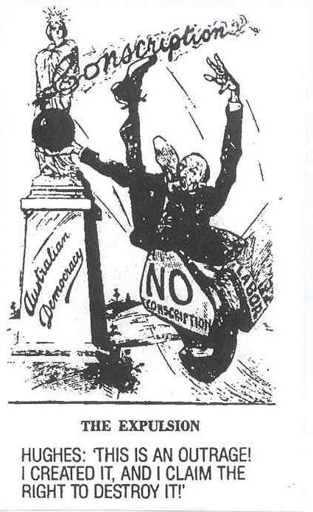

Source 4
(A photograph of Prime Minister William Hughes in London at the end of the war.)
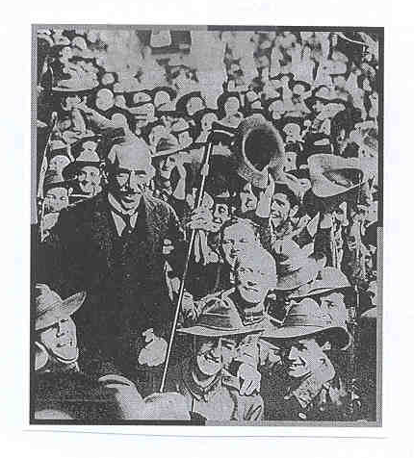

DOCUMENT SET 1
Australia 1880s–1920s continued

Source 5

Changes in Australian prices July 1914 to 1919
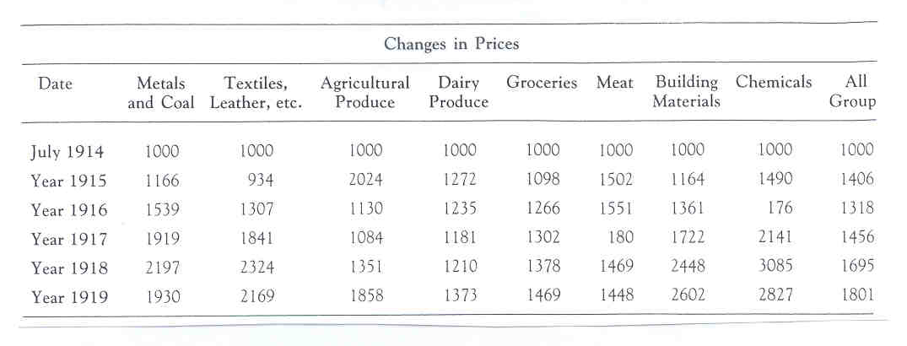

Source 6
(The following extract was published in The West Australian on 25 April 1996.)

Anzac legend unites generations

Their numbers are dwindling but their immortal spirit continues to inspire a nation. ...

In past years, it would have been almost unthinkable to commemorate Anzac Day in the absence of the men whose exploits far from home created the legend that it celebrates. But such is the power of their story and their sacrifice that Australians will continue to honour them long after the last Gallipoli veteran has gone. ...

Other wars have spilt Australian blood and tested the mettle of our fighting men and women, who have not been found wanting. They too have earned the honour and gratitude with which their feats are remembered on Anzac Day by living up to the noble traditions that was forged by the Anzacs.

Although memories of Australian sacrifices in other wars are more recent ... it is the Gallipoli legend that gives the Day its special spiritual significance for Australians. By their growing participation in Anzac Day ceremonies, young people have shown that Gallipoli is more to them than a name in a history book or atlas—and their understanding of and feeling for the legend will ensure its continuation across generations to come.

In the years to come more attention inevitably will shift to veterans of later conflicts—including World War II, Korea and Vietnam... Their stories will still be told ... while those of the original Anzacs will be a legend held in the collective memory of the nation.

DOCUMENT SET 2
Australia 1920s–1950s

Source 1
(The following are comments by Australians who were involved in the Second World War.)

Reg Saunders remembers last days of the battle of Crete.

For two days, we ate no food of any kind... for the last couple days we were without water ― and the result was that we just couldn’t eat. At times, we were almost running to keep up with the battalion. Every one of us knew that it was a race against time ... and that anyone who stopped had had it.

For copyright reasons this text cannot be reproduced in the
online version of this document.

Hilda Lumsden remembers nursing in New Guinea.

I always remember early [19]43 getting the boys off the Kokoda Trail, you know who had been in their clothes for ages and some of their boots had just rotted off. It was like heaven for them to get washed and cleaned and put into bed. But always these big heavy boots encrusted with mud were there as a reminder of what they had been through. ... I think the physical wounds were the worst because our boys were very tough mentally, they really stood up to it wonderfully well, they just wanted to be cured as soon as possible and on their way home.

Source 2
(This painting showing the Kokoda Trail in 1942 and created by G. Browning in 1945 is part of the collection of The Australian War Memorial in Canberra.)

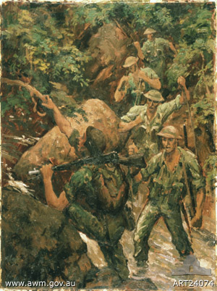

DOCUMENT SET 2
Australia 1920s–1950s continued

Source 3
(This cartoon depicting Prime Minister John Curtin was published in the Bulletin on 6 January 1943. At the time Curtin was addressing the ALP conference in relation to conscripts fighting outside Australian controlled territory.)

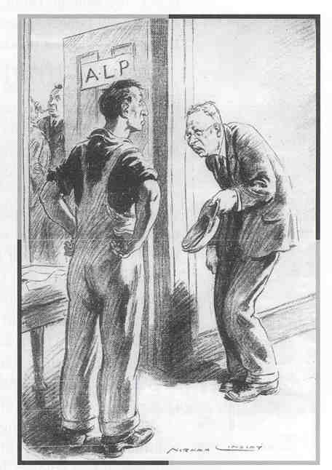
Curtin

Source 4
(A photograph of Prime Minister John Curtin and General MacArthur taken in June 1943.)

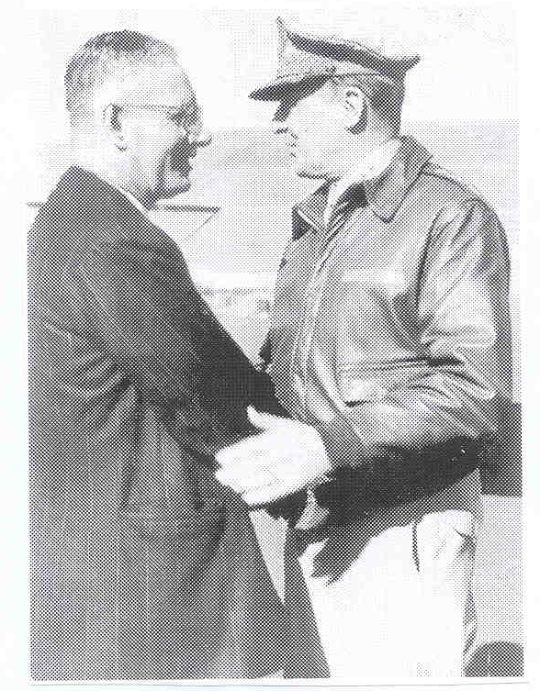

DOCUMENT SET 2
Australia 1920s–1950s continued

Source 5
Men’s and women’s employment 1933 and 1943

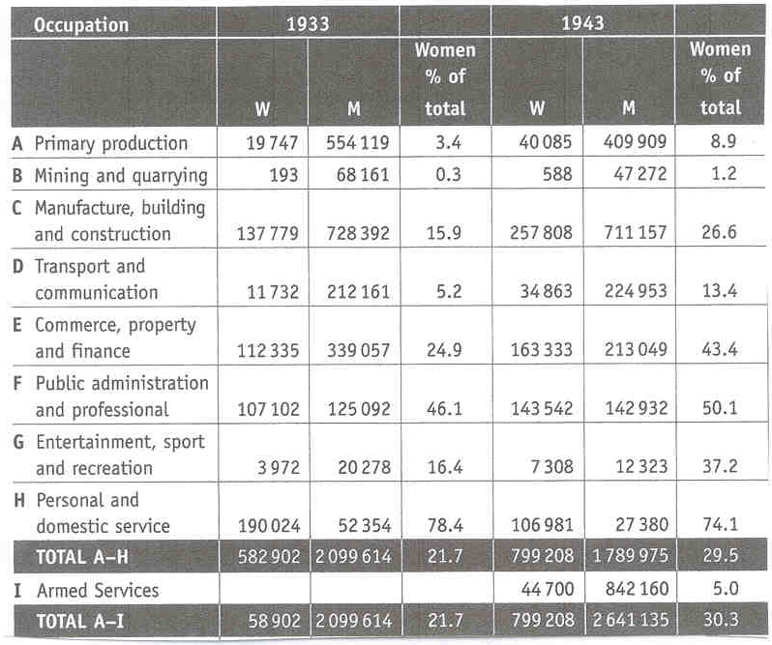

Source 6
(The following extract was published in The West Australian on 25 April 1996.)

Anzac legend unites generations

Their numbers are dwindling but their immortal spirit continues to inspire a nation. ...
In past years, it would have been almost unthinkable to commemorate Anzac Day in the absence of the men whose exploits far from home created the legend that it celebrates. But such is the power of their story and their sacrifice that Australians will continue to honour them long after the last Gallipoli veteran has gone. ...
Other wars have spilt Australian blood and tested the mettle of our fighting men and women, who have not been found wanting. They too have earned the honour and gratitude with which their feats are remembered on Anzac Day by living up to the noble traditions that was forged by the Anzacs.
Although memories of Australian sacrifices in other wars are more recent ... it is the Gallipoli legend that gives the Day its special spiritual significance for Australians. By their growing participation in Anzac Day ceremonies, young people have shown that Gallipoli is more to them than a name in a history book or atlas—and their understanding of and feeling for the legend will ensure its continuation across generations to come.
In the years to come more attention inevitably will shift to veterans of later conflicts—including World War II, Korea and Vietnam… Their stories will still be told ... while those of the original Anzacs will be a legend held in the collective memory of the nation.

DOCUMENT SET 3
Australia 1950s–1990s

Source 1
(The following extracts are comments from soldiers who served in Vietnam.)

Soldier (a)
The forward scout got about half way along [a creek bed] and he just died on the spot, he just crumpled and that was it. We didn’t hear anything, he just crumpled ... A very good friend of mine, he went out to try and fix him up and he only got to the stage where he was bending over him ... [and] he just got shot straight through the heart. Another one of our medics got there and he got shot just straight through the head ... They made me bag them up in green bags and I can still remember my friend’s face. He was smiling.

Soldier (b)
After a while you became accustomed to it ... it was sort of boring, hot humid. You got wet, you got eaten by mosquitoes, the leeches. You were tramping around in water, fighting your way through the bamboo ... I think for the first two months that I was out with the battalion we had not one single contact.

Source 2
(This painting titled Long Tan action, Vietnam, 18 August 1966 and created by B Fletcher in 1970 is part of the collection of The Australian War Memorial in Canberra.)

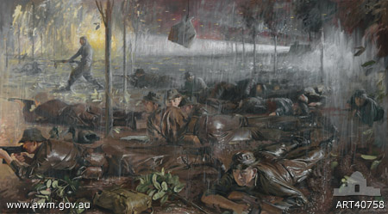
DOCUMENT SET 3
Australia 1950s–1990s continued

Source 3

(This cartoon was published in The Australian in 1966.)

For copyright reasons this image cannot be reproduced in the online version of this document.
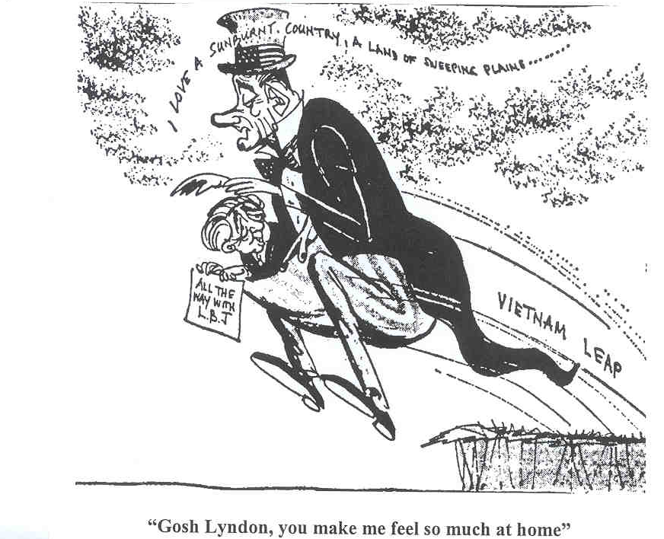

Source 4
(A photograph of President Lyndon Johnson and Prime Minister Harold Holt taken at Canberra airport in 1966.)
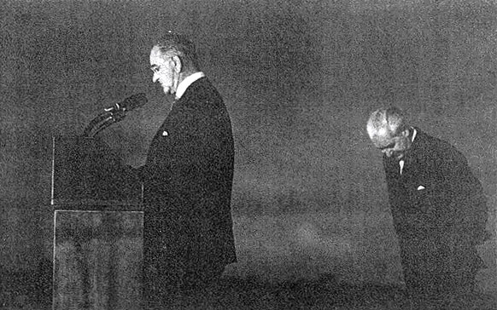
DOCUMENT SET 3
Australia 1950s–1990s continued

Source 5
The following tables were compiled from figures from a number of public opinion polls between 1965 and 1971.

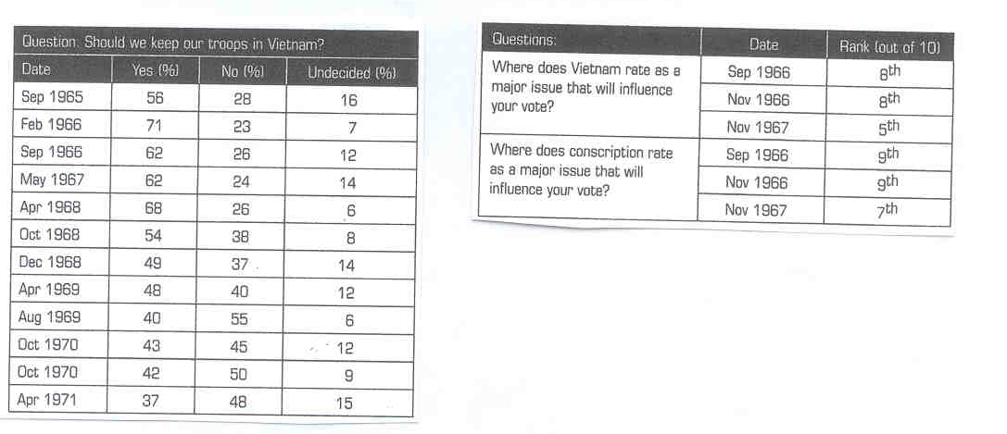

Source 6
(The following extract was published in The West Australian on 25 April 1996.)

Anzac legend unites generations

Their numbers are dwindling but their immortal spirit continues to inspire a nation. ...

In past years, it would have been almost unthinkable to commemorate Anzac Day in the absence of the men whose exploits far from home created the legend that it celebrates. But such is the power of their story and their sacrifice that Australians will continue to honour them long after the last Gallipoli veteran has gone. ...

Other wars have spilt Australian blood and tested the mettle of our fighting men and women, who have not been found wanting. They too have earned the honour and gratitude with which their feats are remembered on Anzac Day by living up to the noble traditions that was forged by the Anzacs.

Although memories of Australian sacrifices in other wars are more recent ... it is the Gallipoli legend that gives the Day its special spiritual significance for Australians. By their growing participation in Anzac Day ceremonies, young people have shown that Gallipoli is more to them than a name in a history book or atlas—and their understanding of and feeling for the legend will ensure its continuation across generations to come.

In the years to come more attention inevitably will shift to veterans of later conflicts—including World War II, Korea and Vietnam… Their stories will still be told ... while those of the original Anzacs will be a legend held in the collective memory of the nation.

SECTION THREE: DOCUMENT STUDY—Unit 2B
DOCUMENT SET 4
Fascism in Italy 1918–1945

Source 1
(A cartoon published in the USA in 1941.)

For copyright reasons this image cannot be reproduced in the online version of this document but may be viewed at http://www.loc.gov/rr/print/swann/herblock/images/s03398u.jpg
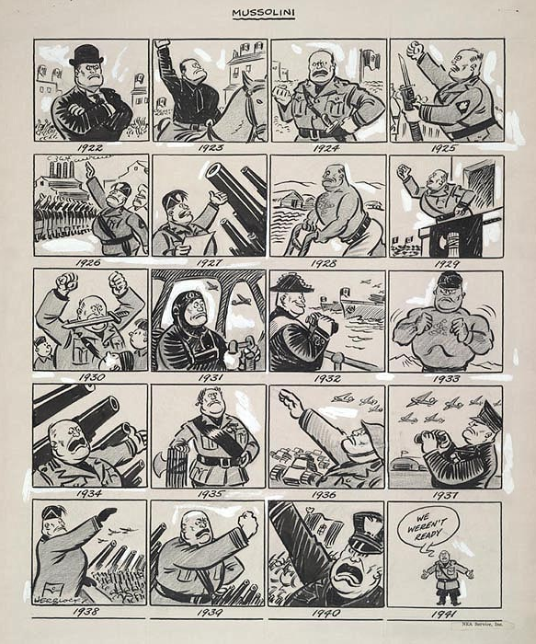

Mussolini
DOCUMENT SET 4
Fascism in Italy 1918–1945 continued

Source 2
(Extract from Benito Mussolini’s The Doctrine of Fascism, 1935.)

The Fascist conception of life stresses the importance of the State and accepts the individual only in so far as his interests coincide with those of the State…..The Fascist conception of the State is all-embracing; outside it no human or spiritual values can exist, much less have value. This understood, Fascism is totalitarian, and the Fascist State….interprets, develops and potentiates* the whole life of the people….

Fascism does not, generally speaking, believe in the possibility or utility of perpetual peace. It therefore discards pacifism….. War alone keys up all human energies to their maximum tension and sets the seal of nobility on those who have the courage to face it…..

A party holding a ‘totalitarian’ rule over a nation, is a new departure in history. There are no points of reference nor of comparison. From beneath the ruins of liberal, socialist, and democratic doctrines, Fascism extracts those elements which are still vital….Granted that the XIXth [19th] century was the century of socialism, liberalism and democracy, this does not mean that the XXth [20th] century must also be the century of socialism, liberalism, democracy. We are free to believe that this is the century of authority, a century tending to the ‘right’, a Fascist century. If the XIXth [19th] century was the century of the individual (liberalism implies individualism) we are free to believe that this is the ‘collective century, and therefore the century of the State…….

* potentiate = endows with power, makes possible

DOCUMENT SET 4
Fascism in Italy 1918–1945 continued

Source 3
(A painting created in 1935. Please note the three men standing are fascist officials.)

For copyright reasons this image cannot be reproduced in the online version of this document.

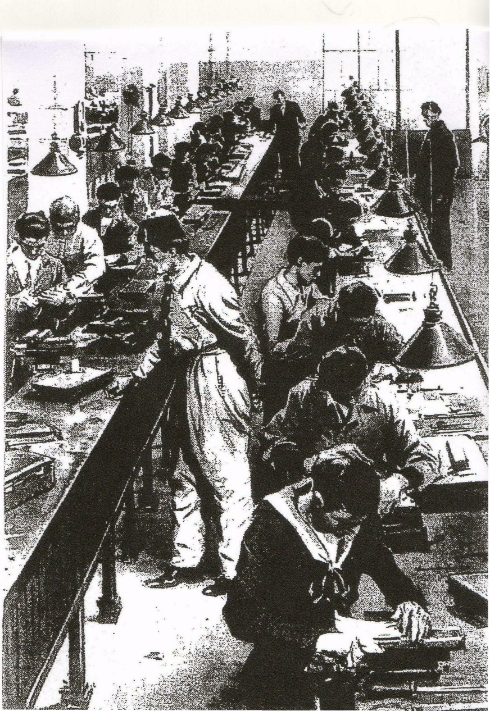

DOCUMENT SET 5

Nazism in Germany 1918–1945

Source 1
(A cartoon published in the British magazine Punch in 1932.)

For copyright reasons this image cannot be reproduced in the online version of this document.
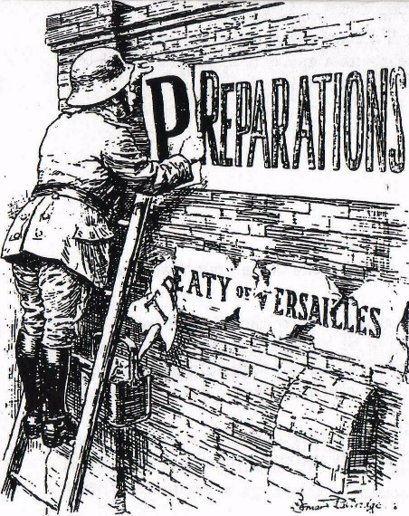

FOR DEFENCE ONLY

DOCUMENT SET 5

Nazism in Germany 1918–1945 continued

Source 2
(i) (Extract from Hitler’s Reichstag peace speech on May 17, 1933, in response to the Geneva Conference on Disarmament.)

For copyright reasons this text cannot be reproduced in the
online version of this document.
It is in the interests of all that present day problems should be solved in a reasonable and peaceful manner… The application of violence of any kind in Europe could have no favourable effect upon the political and economic position…. The outbreak of such unlimited madness would necessarily cause the collapse of the present social and political order….

(ii) (Extract from Hitler’s speech to the German people on October 14, 1933, following announcements from the Disarmament Conference.)

For copyright reasons this text cannot be reproduced in the
online version of this document.
Since the Reich government perceives in this procedure the discrimination of the German people that is equally unjust and degrading it sees itself no long able, under such circumstances as a second class nation without rights, to participate further in negotiations which could only lead to further, new impositions. While the German Reich government thus testifies its unshakable will to peace, it declares in view of these humiliating and dishonouring unreasonable demands, with the greatest regret, that it must leave the Disarmament Conference. It must also therefore announce its withdrawal from the League of Nations.

It places this decision, together with a new belief in a policy of sincere love of peace and readiness to negotiate, before the German people for their consideration and expects from them an expression of the same love of peace and willingness for peace, but also of the same notion of honour and the same resolve…..

DOCUMENT SET 5

Nazism in Germany 1918–1945 Continued

Source 3
(Previously unemployed workers assemble to begin work on the first autobahn, September 1933.)

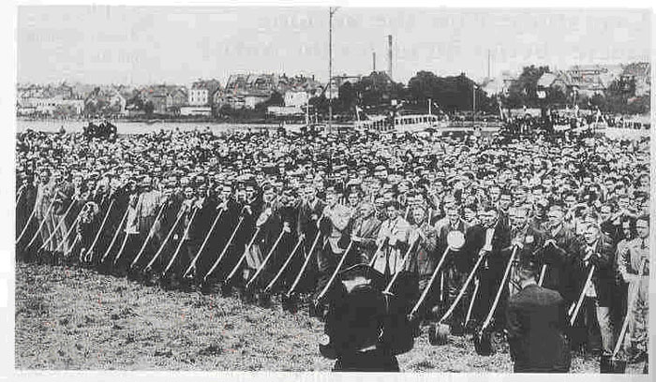

DOCUMENT SET 6

Civil Rights movement in the USA: 1940s–1970s

Source 1
(Cartoon appearing in The Washington Post, August 14th 1960.)

For copyright reasons this image cannot be reproduced in the online version of this document but may be viewed at http://www.loc.gov/rr/print/swann/herblock/images/s03533u.jpg
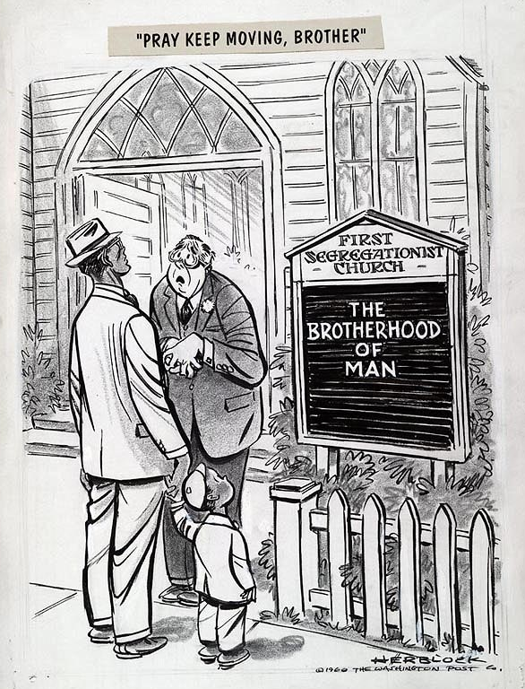

PRAY KEEP MOVING, BROTHER
DOCUMENT SET 6

Civil Rights movement in the USA: 1940s–1970s continued

Source 2

(Stokeley Carmichael addressing students at Berkeley University in California, October 1966.)

For copyright reasons this text cannot be reproduced in the online version of this document but may be viewed at http://www.americanrhetoric.com/speeches/stokelycarmichaelblackpower.html
(scroll down: 7th and 8th paragraph from the end)
If we were to be real and to be honest, we would have to admit -- we would have to admit that most people in this country see things black and white. We have to do that. All of us do. We live in a country that’s geared that way. White people would have to admit that they are afraid to go into a black ghetto at night. They are afraid. That's a fact. They're afraid because they’d be "beat up," "lynched," "looted," "cut up," etcetera, etcetera. It happens to black people inside the ghetto every day, incidentally, and white people are afraid of that. So you get a man to do it for you -- a policeman. And now you figure his mentality, when he's afraid of black people. The first time a black man jumps, that white man going to shoot him. He's going to shoot him. So police brutality is going to exist on that level because of the incapability of that white man to see black people come together and to live in the conditions. This country is too hypocritical and that we cannot adjust ourselves to its hypocrisy.

The only time I hear people talk about nonviolence is when black people move to defend themselves against white people. Black people cut themselves every night in the ghetto — Don't anybody talk about nonviolence. Lyndon Baines Johnson is busy bombing the hell of out Vietnam — Don't nobody talk about nonviolence. White people beat up black people every day — Don't nobody talk about nonviolence. But as soon as black people start to move, the double standard comes into being.

DOCUMENT SET 6

Civil Rights movement in the USA: 1940s–1970s continued

Source 3
(Police attack Civil Rights marchers with dogs and fire hoses in Birmingham, Alabama, May 3rd 1963.)

For copyright reasons this image cannot be reproduced in the online version of this document but may be viewed at http://rising.blackstar.com/images/historicphotoslarge/civil-right-dogs1.jpg
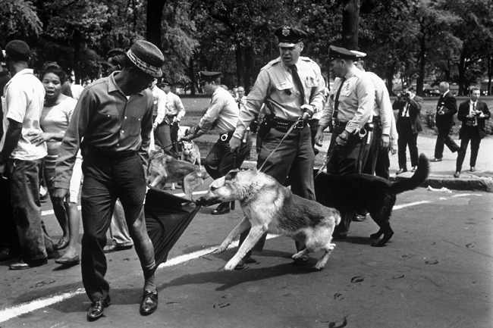

ACKNOWLEDGEMENTS

Document SET 1—AUSTRALIA 1800s–1920s

Source 1: Studies of Society and Environment. (1997). 1(97), p. 43. [Melbourne: Ryebuck Media]

Source 2: Crozier, F. (1919). The Beach at Anzac (ART24074) [Oil on canvas, 61 x 45.4cm]. Retrieved October, 2006, from Australian War Memorial website: http://www.awm.gov.au/database/collection.asp [Collections Search].

Source 3: McKinlay, B. (1988). A Century of Struggle: The ALP A Centenary History.
Blackburn, Vic.: Collins Dove, p. 57.
Claude Marquet cartoon used by permission Mitchell Library, State Library of New South Wales.

Source 4: Cohen, B. (1998). Ideals and Reality 1. Melbourne: Addison Wesley Longman, p. 93.

Source 5: Spenceley, G. (1988). The Search for Security: A Modern World History.
Melbourne: Oxford University Press, p. 225.

Source 6: Anzac legend unites generations. (1996, April 25). The West Australian.
Reproduced courtesy of The West Australian newspaper.

DOCUMENT SET 2—AUSTRALIA 1920s–1950s

Source 1: Laidler, R., & White, S. (1991). Australia 1900–1950: Light on the Hill. Caulfield East, Vic: Edward Arnold, p. 193.

Studies. (1995). Issue 3/1995, p. 10. [Melbourne: Ryebuck Media]

Source 2: Browning, G. (1945). Kokoda Trail (ART24074) [Oil on canvas, 61 x 45.4cm]. Retrieved October, 2006, from Australian War Memorial website: http://www.awm.gov.au/database/collection.asp [Collections Search].

Source 3: Cohen, B. (1998). Ideals and Reality 1. Melbourne: Addison Wesley Longman, p. 117.
Norman Lindsay cartoon used by permission H., C. and A. Glad.

Source 4: PM John Curtin shaking hands with General Douglas MacArthur, Sydney 8 June 1943 [Photograph]. (1943). Retrieved October, 2006, from John Curtin Prime Ministerial Library website: http://john.curtin.edu.au/macarthur/graphics/00376_69l.jpg.

Source 5: Studies of Society and Environment. (2002). 3, p. 52. [Melbourne: Ryebuck Media]

Source 6: Anzac legend unites generations. (1996, April 25). The West Australian.
Reproduced courtesy of The West Australian newspaper.

DOCUMENT SET 3—AUSTRALIA 1950s–1990s

Source1: Studies of Society and Environment. (2004). 2, pp. 29–30. [Melbourne: Ryebuck Media]

Source 2: Fletcher, B. (1970). Long Tan action, Vietnam, 18 August 1966 (ART40758) [Oil on canvas 152 x 175cm]. Retrieved October, 2006, from Australian War Memorial website: http://www.awm.gov.au/database/collection.asp [Collections Search].

Source 3: King, J. (1978). A Cartoon History of Australia. Adelaide: Savvas Publishing, p. 404.

Source 4: Moore, D. (1988). President Johnson and Prime Minister Holt at Canberra Airport—1966 [Photograph]. In J. Rickard, Australia: A Cultural History (p. 214). London: Longman. (Photograph taken 1966)
Photograph © Estate of David Moore.

Source 5: Studies of Society and Environment. (2004). 3, p. 24. [Melbourne: Ryebuck Media]

Source 6: Anzac legend unites generations. (1996, April 25). The West Australian.
Reproduced courtesy of The West Australian newspaper.

DOCUMENT SET 4—FASCISM IN ITALY 1918–1945

Source 1: Block, H. (1941). [Mussolini cartoon]. Retrieved July, 2007, from Library of Congress website: http://www.loc.gov/rr/print/swann/herblock/images/s03398u.jpg.

Source 2: Mussolini, B. (1935). The Doctrine of Fascism. In Bollen, J. D., & Cosgrove, J.J. (1985). Two Centuries: A Profile of Modern History. Melbourne: Pitman, pp. 496–497.

Source 3 Miller, S.T. (1990). Mastering Modern European History. Basingstoke, UK: Macmillan Education.

DOCUMENT SET 5—NAZISM IN GERMANY 1918–1945

Source 1: Partridge, B. (1932). For Defence Only [Cartoon]. In Cloake, J. (1997). Germany 1918–1945. Oxford, UK: Oxford University Press, p. 26.

Source 2: Holt, R.F., & Pickard, A., (1991). Democracy, Dictatorship, Destruction. Melbourne: Longman Cheshire, pp. 281–282.

Source 3: Lacey, G., & Shephard, K. (2006). Germany 1918–1945. London: Hodder Murray, p. 124.

DOCUMENT SET 6—CIVIL RIGHTS MOVEMENT IN THE USA 1940s–1990s

Source 1: Block, H. (1960). “Pray Keep Moving, Brother” [Cartoon]. Retrieved July 17, 2007, from Library of Congress website: http://www.loc.gov/rr/print/swann/herblock/images/s03533u.jpg.

Source 2: Carmichael, S. (1966). Black Power [Transcript of speech]. Retrieved July 17, 2007, from American Rhetoric website: http://www.americanrhetoric.com/speeches/stokelycarmichaelblackpower.html.

Source 3: Moore, C. (1963). [Photograph of civil rights marchers and police]. Retrieved July 17, 2007, from Black Star Rising website:
http://rising.blackstar.com/images/historicphotoslarge/civil-right-dogs1.jpg.
Published by the Curriculum Council of Western Australia
27 Walters Drive
OSBORNE PARK WA 6017

